ACO Task:-
- time Kevin prints a script, it prints out two pages with a blank second page. Please combine the 2 sentences circled in the picture attaced, and decrease the font slightly . hopefully that will fix that issue.

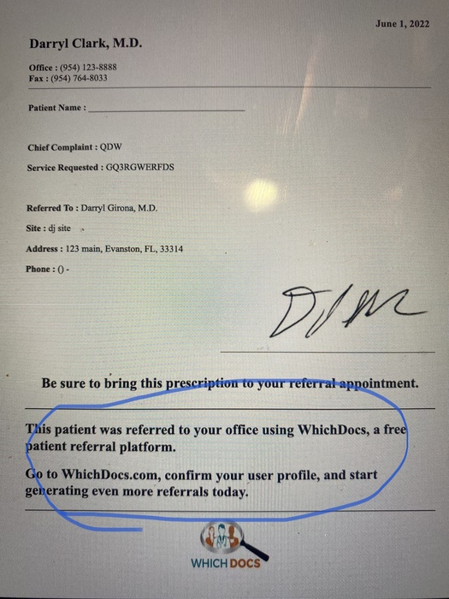

while you're add it.... Above the circled text mentioned above, please add
"Dear Dr. ______"
with the blank being filled by the referred to Provider's last name.

Front-end time --- 1 Hours
Back-end time-- 0 Hour

Done from Front-end site and uploaded

- FDU signup screen needs to also mention you need at least 1 number. currently says

"Password must be at least 8 Chars, One Upper & Lower Case and One special character"

Front-end time --- 0.5 Hours
Back-end time-- 0 Hour
Done from Front-end site and uploaded

- When a provider adds a new insurance, it does add it to the list as "to be verified" but we don't know it is there. Can you please program it to send an email to info@whichdocs, title new insurance to be verified, and if possible , the name of the insurance and the provider that requested it.

1^{st part}
Front-end time --- 0 Hours
Back-end time-- 5 Hours

Secondly, is it possible for providers to suggest multiple new insurances in their profile page, separated by commas, so they don't have to do them one at a time?

2nd part
Front-end time --- 4 Hours
Back-end time-- 8 Hours

Done from Front-end site and uploaded

- Superadmin / Affiliations. Within an individual affiliation (ex:
Broward County Medical Association) "Export Provider list" doesn't seem to download anything

Front-end time --- 2 Hours
Back-end time-- 5 Hours

Done from Front-end site and uploaded

- Superadmin / Providers. if you search providers with a screen for Broward County Medical Association affiliation, there are 573 results and oddly does not include Kevin Shrock. If you go to Superadmin / Affiliations and look at the list, there are 579 AND Kevin in included.

Front-end time --- 2 Hours
Back-end time-- 5 Hours

- Unregistered Providers can currently reset a password even if they are not yet registered, as long as we already have their email in our database. That is not right.

IF a provider's Email address is in our database AND they are registered, they should receive the PW reset email.

otherwise,

IF EITHER
[a provider's Email address is in our database AND they are NOT yet registered]
OR
[their email address is NOT in our database],
they should see a message "That email is not yet registered. Please go back to whichdocs.com and click Signup"

Front-end time --- 0.5 Hours
Back-end time-- 5 Hours

Total Front-end time --- 10 Hours
Total Back-end time-- 28 Hours

